Math Projects for 5/4-5/8: Answer the questions on another piece of paper. Send a picture me by email or text.

A.
B. C. D. E. F. G. H.

- Sort shapes are the following colors. Yellow Red Blue

- Sort the shapes by shapes. Square Rectangle Triangle Circle

- Sort the shapes by size. Big Small

cylinder cube 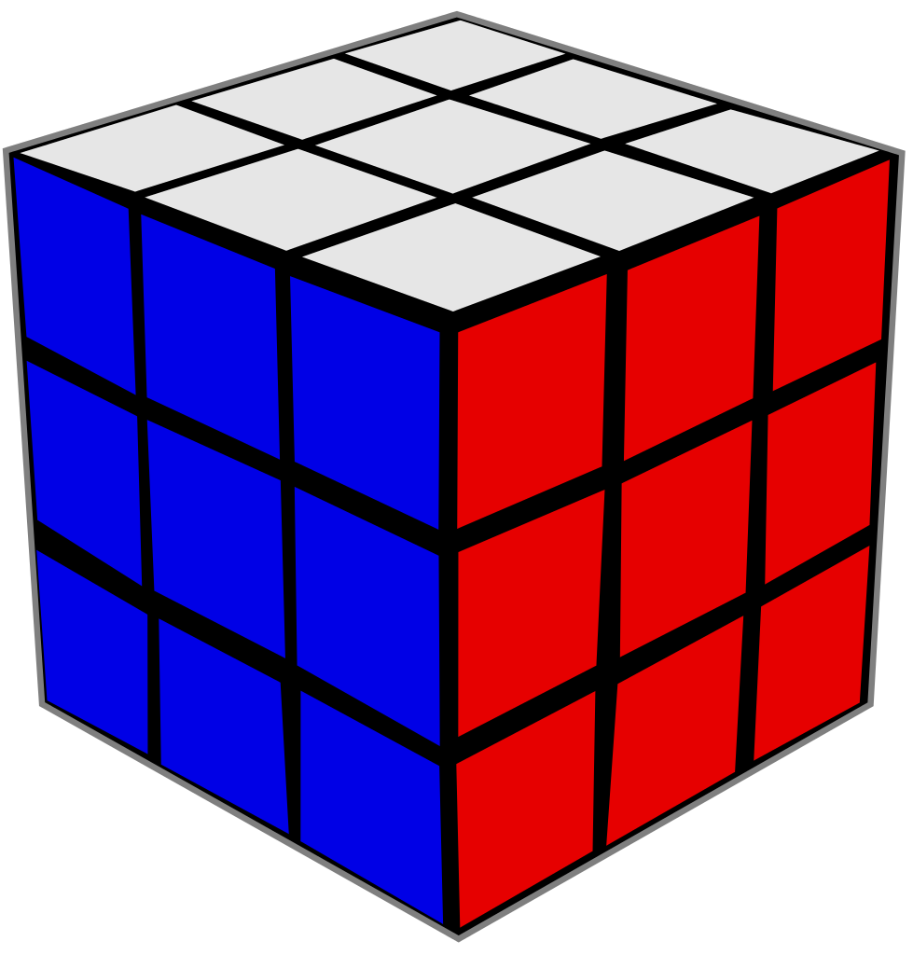 sphere 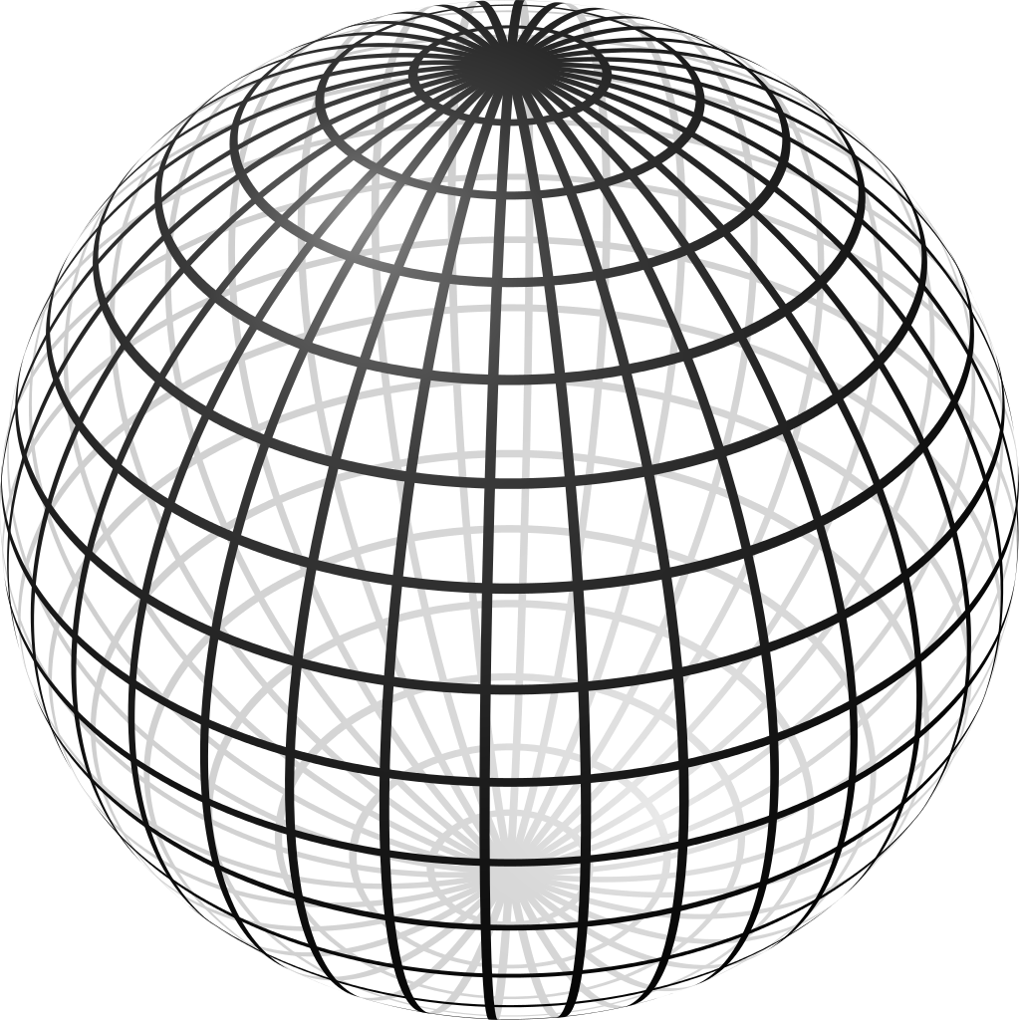

- Which shape doesn’t stack?
- How many flat shapes does a cylinder have?
- Draw 14 circles.
- Draw 20 squares.
- Put the numbers in order. 17, 19, 20, 18
- What is lighter than a marker?
- Draw a line that is shorter than your pencil.
Triangles
Circles
Squares

  - How many triangles do have?
  - How circles and squares do you have? _____ + ______ = _______
- Fill in the blanks using the pictures:

5 = ______+______ 8-______=______
Language Arts projects for 5/4-5/8
- Sing the ABC song and write missing letters.
_______ B C ________ E _______ G H ________
_________ K L M ________ O P ________ R
_______ T U V _______ X _______ Z
- Write what letter do you hear in the middle of each picture: a e i o u
a. b. 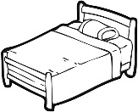 c. d. 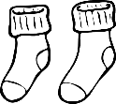 e. 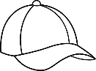
f. g. h. 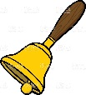 i. 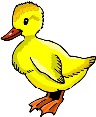

- Read at least 3 stories using raz-kids or any other stories if you can't get online. Please make sure your student is only reading stories for their raz-kid account. I do keep track of how much they read.

- Make a card for your mom because mother’s day is on Sunday.

- Draw a picture to go with the memory verse.
