Science project instructions for 5/11-5/15: Read about digestion and follow the directions for the science experiment. Answer the questions and send a picture of your work to me.
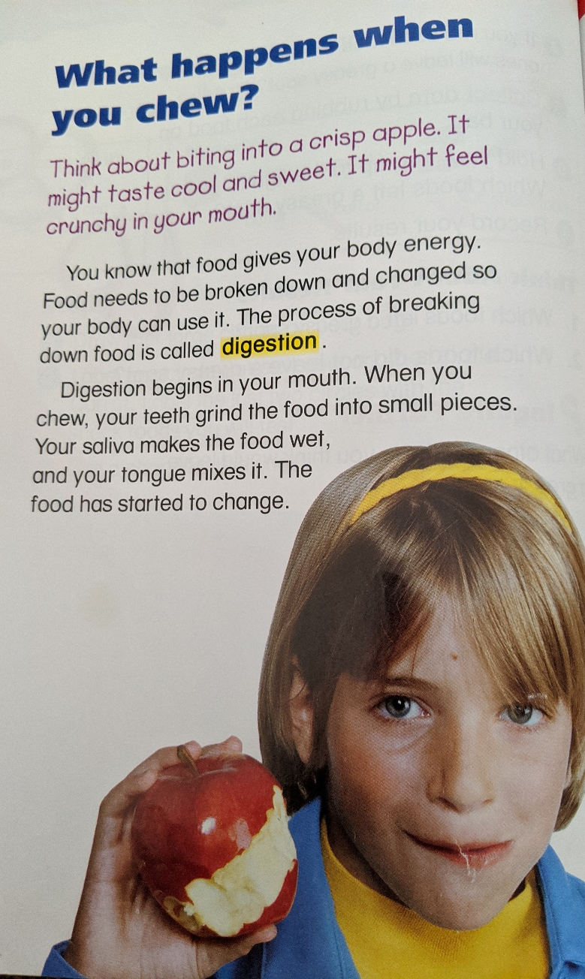
Observe how food can be changed.
You will need 2 zip lock bags, 2 soda crackers, and water.
- Put one cracker in each bag.
- Break one of the crackers into small pieces. Leave the other cracker whole.
- Add water to both bags. Seal the bags.
- Predict what will happen to the crackers if you shake the bag.
- Shake each bag 10 times. Compare the crackers.

 | What I think will happen | Which one was softer?
Broken up cracker with water
Whole cracker with water

What is digestion?

How does chewing and saliva help digestion?

Social Studies project instructions for 5/11-5/15: Read the social studies pages and answer the questions below. Take a picture of the page and email or text it to me.
Write which word finishes each sentence.
- A (map, statue) might show a route traveled by immigrants.
- Immigrants coming to New York would see (Mount Rushmore, the Statue of Liberty).
- Go to (Michigan, Ellis Island) to learn more about immigrants.
- Go to (Rhode Island, Angel Island) to learn about immigrants from China.
- My family immigrated from…
