Language Arts instructions for 3/30-4/3 (#1 for 1st and 2nd only)
- . Write the answers to the questions and take a picture of it. Send the picture to me by email or text it to me.
- Read at least 3 stories using raz-kids or any other stories if you can't get online. Please make sure your student is only reading stories for their raz-kid account. I do keep track of how much they read.
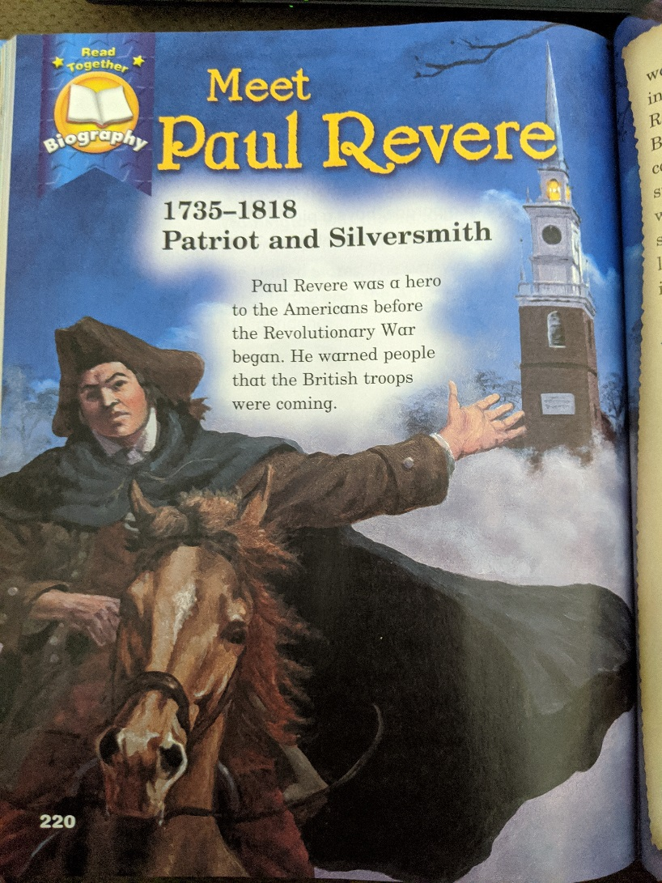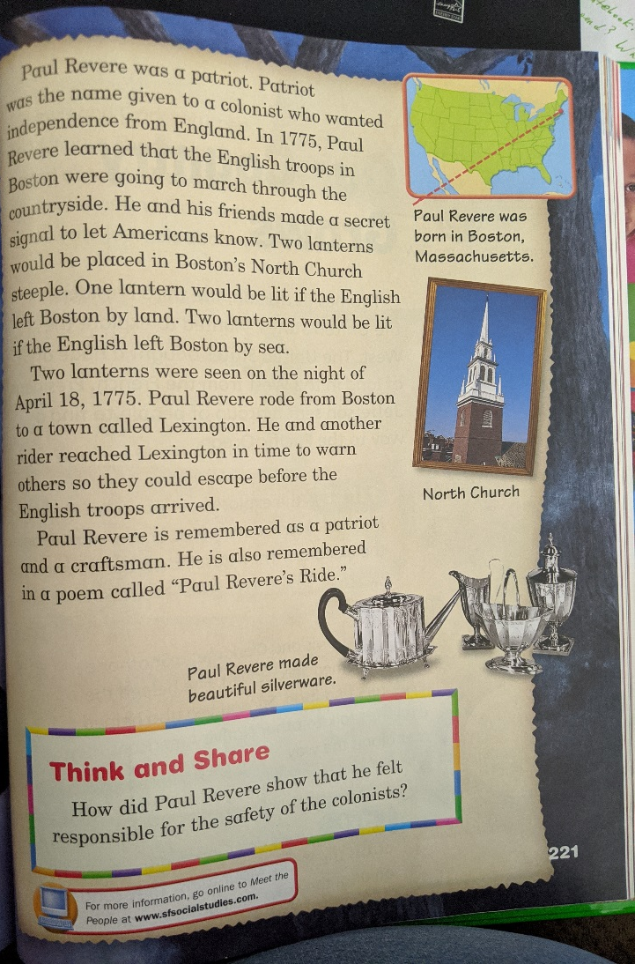

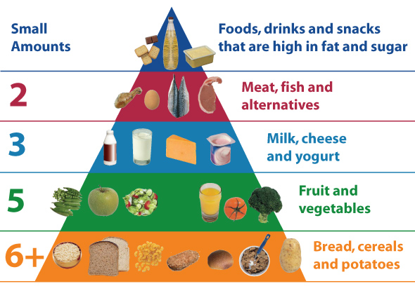

Science project instructions for 3/30-4/3:

- Fill in a food pyramid with what you are eating. (I am posting an example.)
- Watch a video and take a quiz on http://jr.brainpop.com/ if your internet will let you.

Social Studies projects instructions for 3/30-4/3: (#2 for 1st and 2nd only)
- Make a timeline about your life. Start with the year of your birth, write 2 other events, and end with 2020. (I am sending an example but use years instead of months)
- Find the distances on the map picture I am including.
