Math Projects for 3/30-4/3

- Measure five things in your house. Put them in order from shortest to longest.
Shortest _________________ is ________ inches
_________________ is ________ inches
_________________ is ________ inches
_________________ is ________ inches
Longest _________________ is ________ inches
- Look at a clock and write three times and what you were doing at that time.
At __________________ I was _____________________.
At __________________ I was _____________________.
At __________________ I was _____________________.
- Make a picture graph about your family’s favorite food.

Favorite Food

Which food got the most votes?
Which got the least votes?
What is the difference between them?

- How many flat shapes does each shape have?
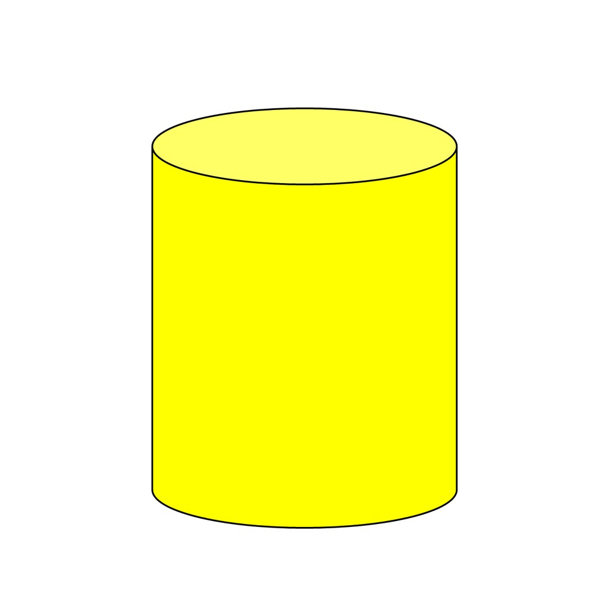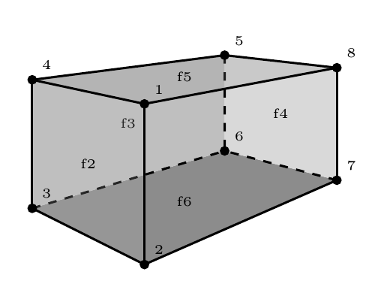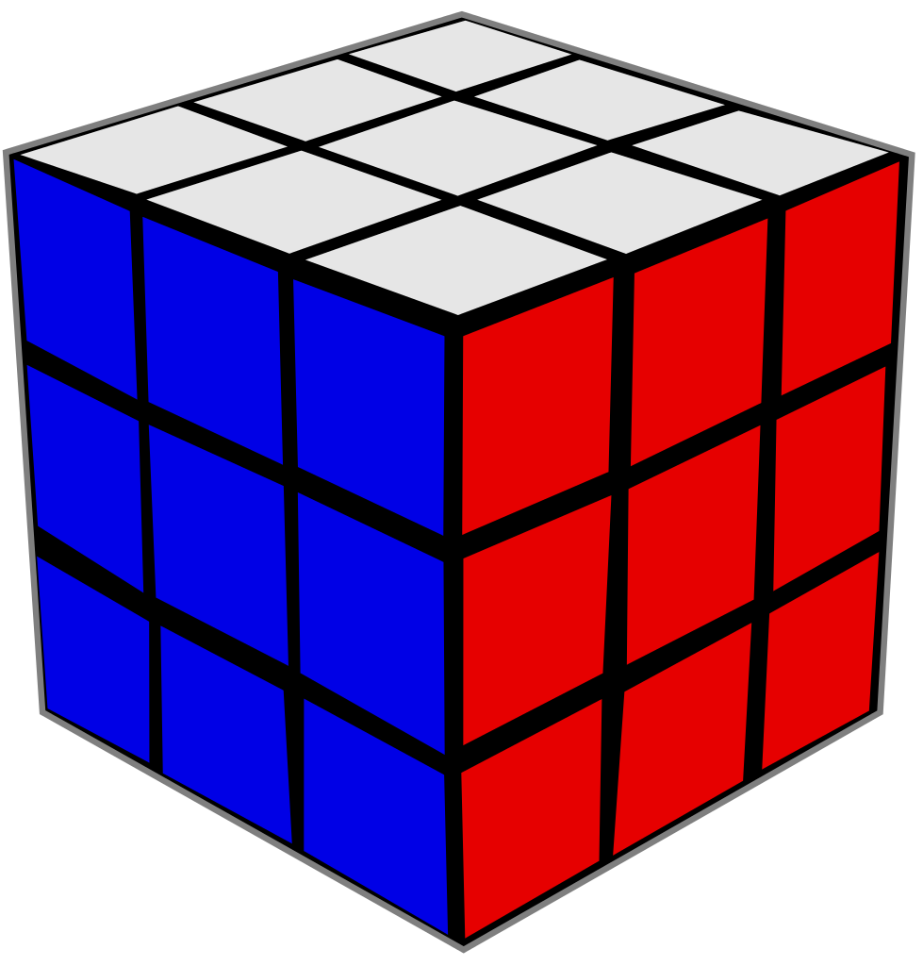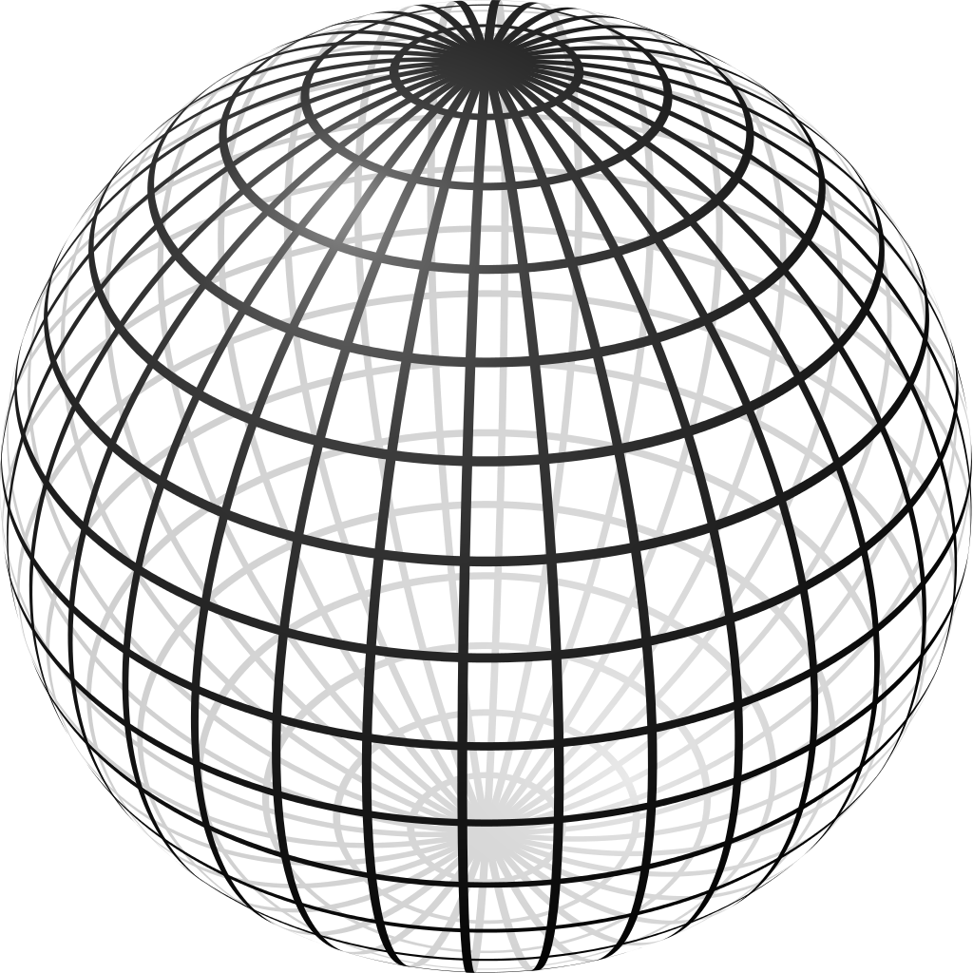
cylinder rectangular prism cube cone sphere

Which shape has only curves?

- Add and subtract the following numbers:

25 42 36 97 35 62
+14 +27 +25 -86 -21 -17

