Math Projects for 4/13-4/17: Answer the questions on another piece of paper. Send a picture me by email or text.

- What is the name of each shape? sphere, cube, cylinder, cone
a.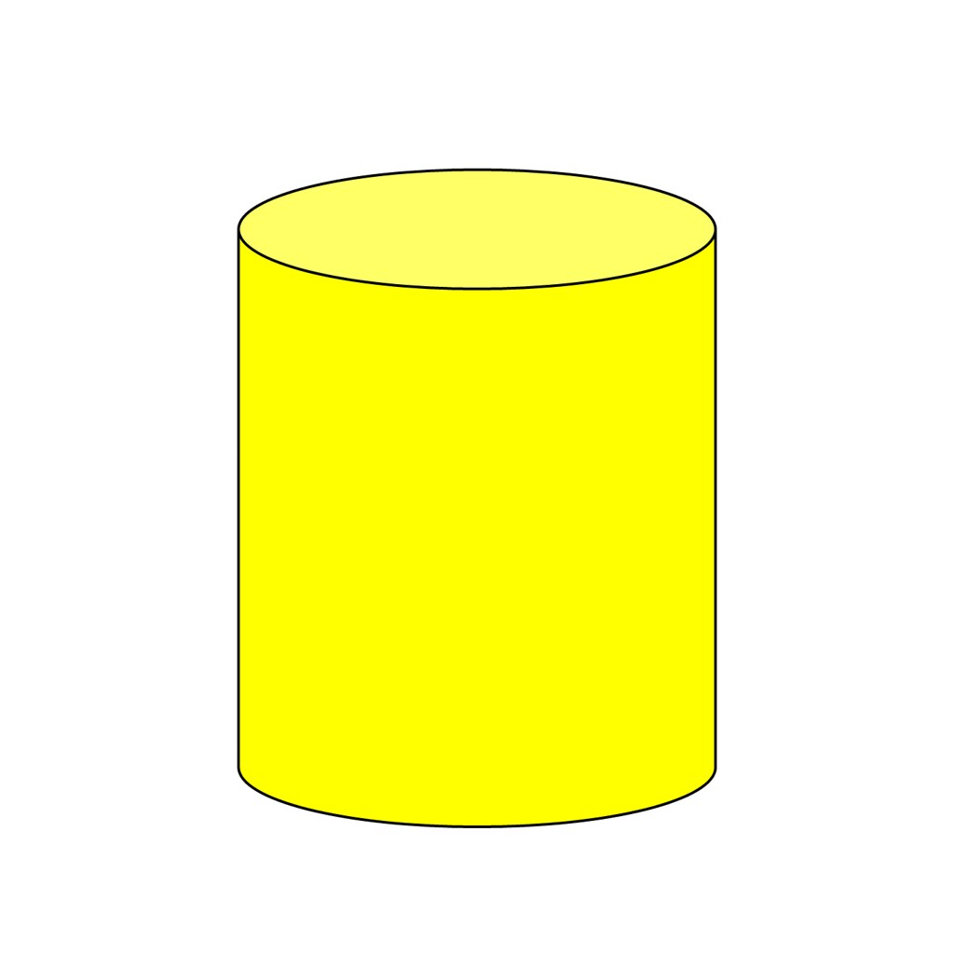 b.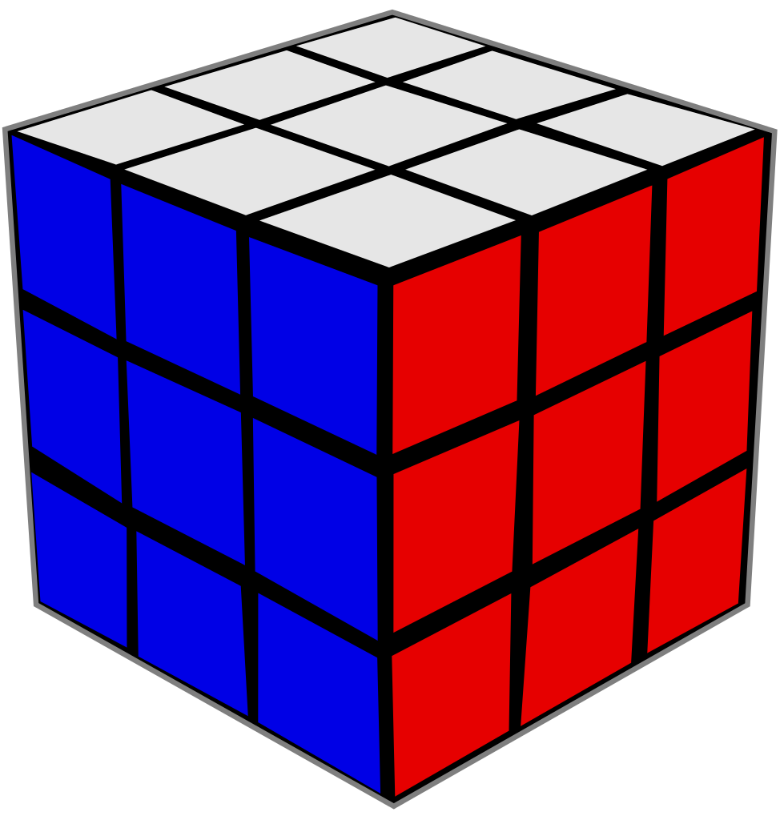 c. d.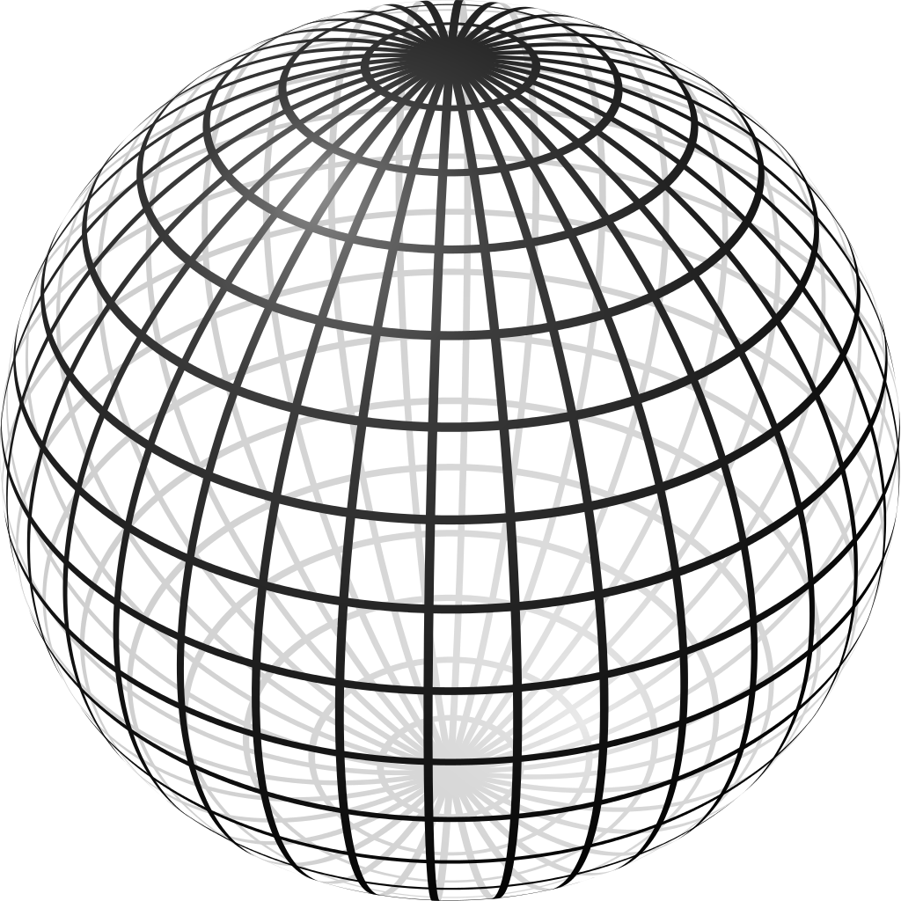

Which 3 shapes roll? Which 3 shapes slide? Which 2 shapes stack?

- Draw 11 triangles, 15 rectangles, and 13 circles.

- Put the following numbers in order:

17 20 19 18

- Count to 100. What comes after 65? What comes after 90? What comes after 28?

- Use counters or fingers fill in the blanks:

5-_______=2 7-_______=5 8-_______=3

Language Arts projects for 4/13-4/17

- Sing the ABC song and write the alphabet every day.

- Draw 5 words that start with each of the following letters: T, U, and V. Practice the sounds they make.

- Jack Jack got out of his cage during spring break. It was night when he got out and he was not found all day. The next night he got thirsty and came back to the living room to get a drink of water and was put back in his cage. Write a story of what he did all day.

- Draw a picture to go with the memory verse.
