Math Projects for 4/13-4/17: Answer the questions on another piece of paper. Send a picture me by email or text.

- Make tally marks to show how many pillows are in your house.
- What time does the clock say? 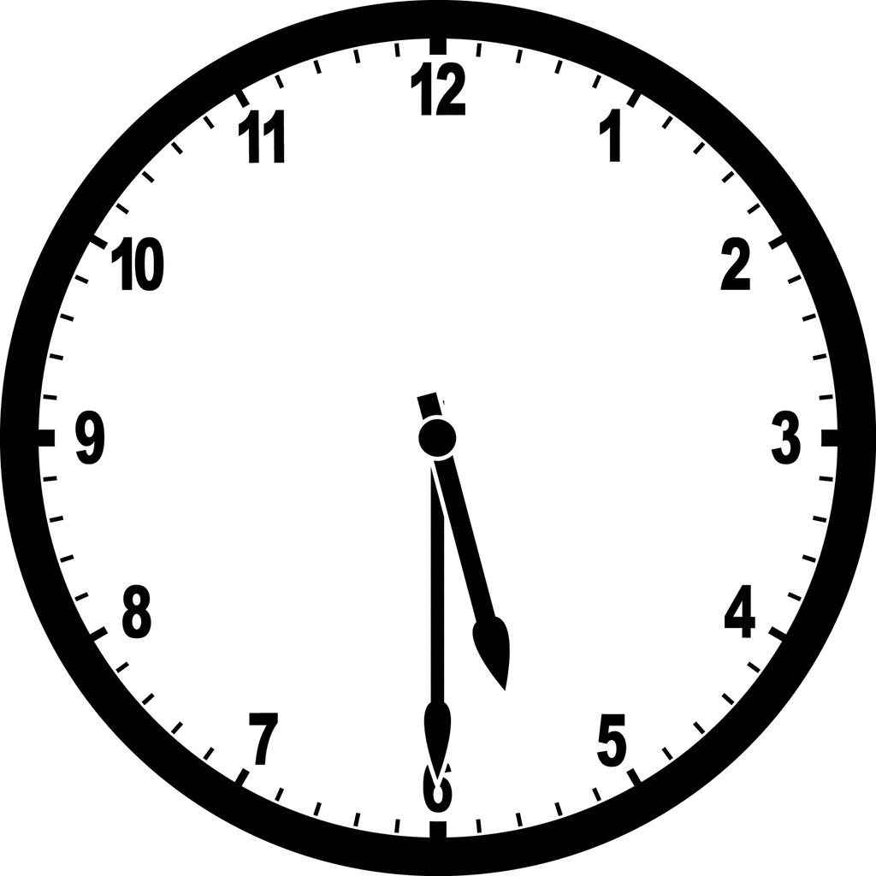
- How many sides and vertices (corners) does each have?
  - Pentagon
  - Hexagon
  - Triangle

- What is each shape? trapezoid, square, rectangle

  - b. c.

- Compare the following numbers using <, >, or =:

13______31 57_______57 23_______21

- Fill in the missing numbers: 109, 110, 111, _______, 113… 120, 121, 122, _______, 124

- What is 10 less and 10 more than the following numbers?

10 Less |  | 10 More
 | 52
 | 31
 | 16

- Which shape or shapes are:
  - curved?
  - has more than 3 sides?
  - has 4 vertices (corners)?
  - not curved?

Language Arts projects for 4/13-4/17

- Spelling- to, school, do, you, good, put, books, tooth, soon, look
  - Which words have an: o oo ou u

  - Put the words in alphabetical order.

- Phonics- Write the vowel (A, E, I, O, U) that starts each word.
a.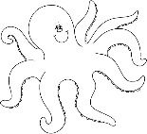 b. 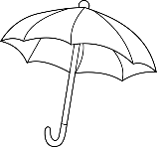c. 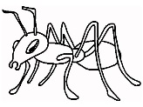 d. 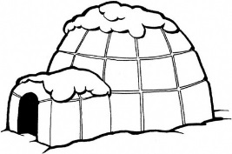 e.
- Phonics- Write the vowel (A, E, I, O, U) that is in the middle of each word.
a. 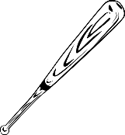 b. 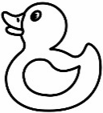 c. 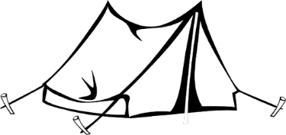 d. 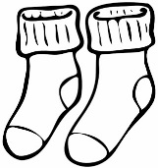 e. 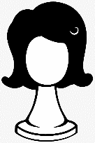
- Reading- Read about Sojourner Truth and answer the question. (I attached the story.)

- English- Jack Jack got out of his cage during spring break. It was night when he got out and he was not found all day. The next night he got thirsty and came back to the living room to get a drink of water and was put back in his cage. Write a story of what he did all day.

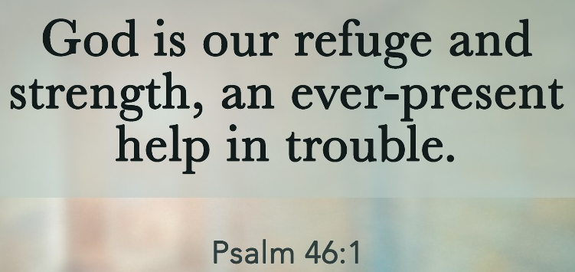

- Handwriting- Write Psalm 46:1 as neatly as you can.

