**Science project instructions for 4/20-4/24:** Read about the heart and lungs and answer the questions on another paper. Take a picture of the page and email or text it to me.

1. Read the page about the heart and lungs. Answer the 3 questions.
2. Draw the heart, lungs, veins and arteries where it goes in the body.

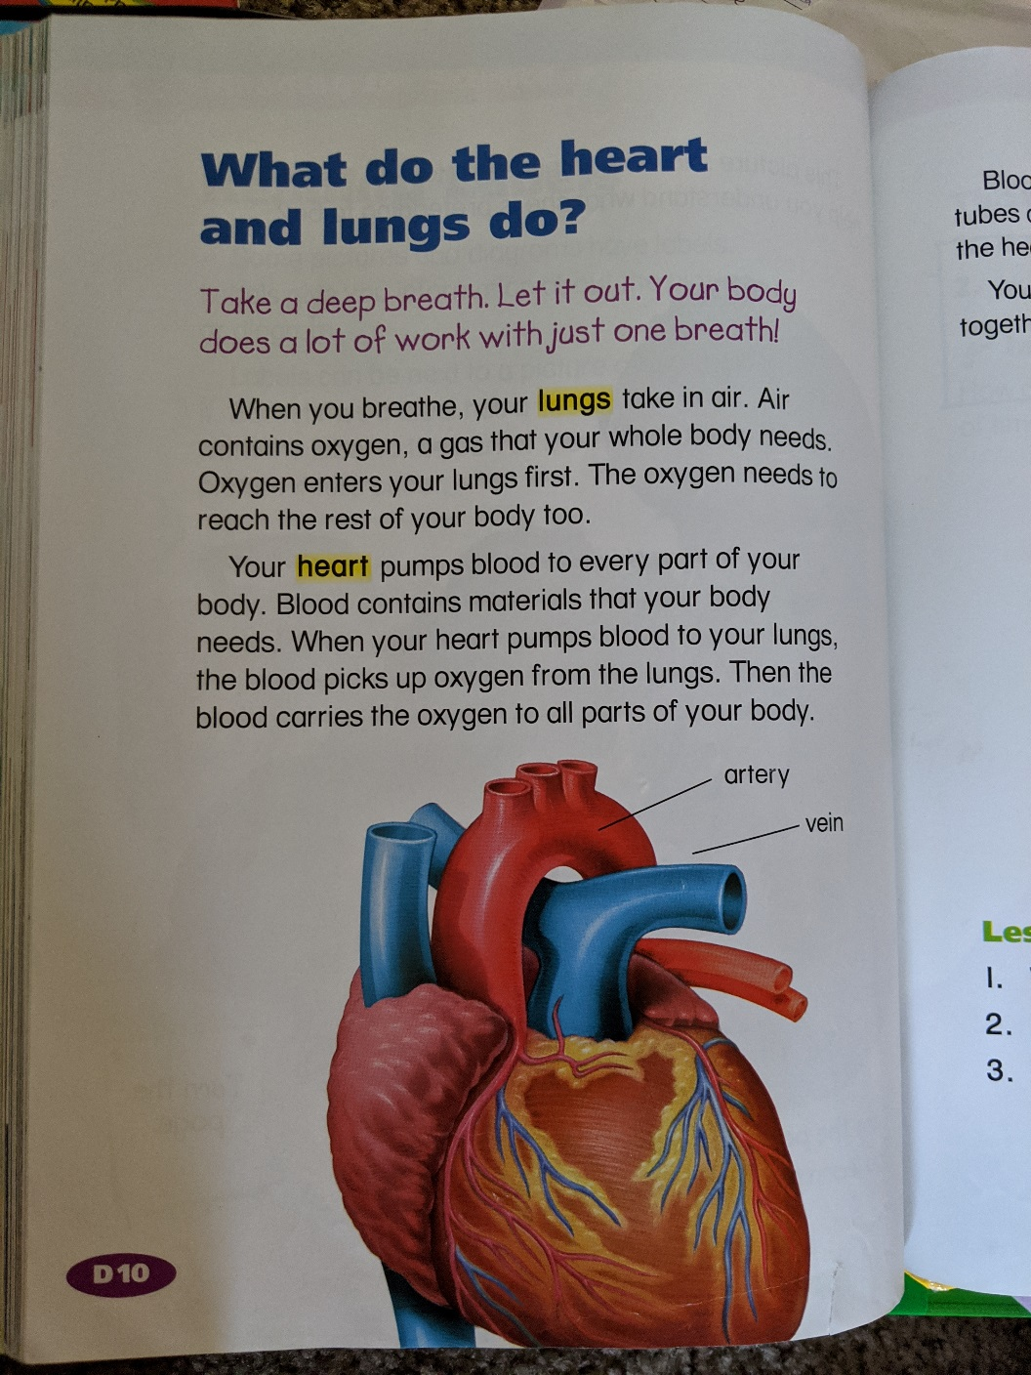 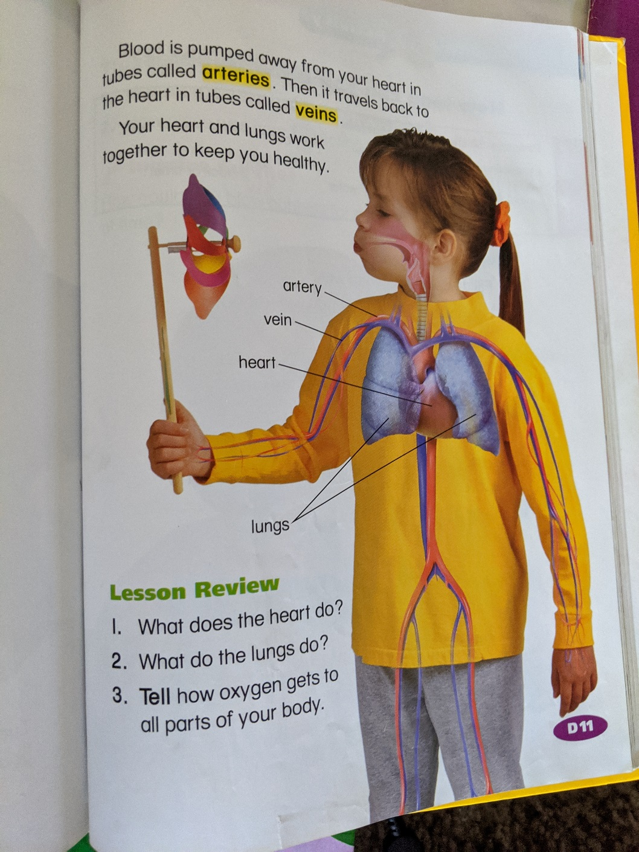



**Social Studies projects instructions for 4/20-4/24:** Read about the U.S. Colonies and answer the following questions after on a piece of paper. Email or text the picture to me.

Which 5 sentences are true about life in the colonies?

1. There was not enough food.
2. The colonist went back to England.
3. Settlements were built.
4. Some colonists looked for gold.
5. Everyone started farms.
6. The winter was hard.
7. The colonists and Wampanoags celebrated the first Christmas.
8. Squanto helped the colonists look for gold.
9. John Smith helped the colonists know how to work better.

