Math Projects for 4/27-5/1: Answer the questions on another piece of paper. Send a picture me by email or text.

  - Draw a red line longer than the purple line.
  - Draw a blue line shorter than the purple line.
  - Draw a yellow line the same as the purple line.

- Find a cereal box.
  - What are 2 things taller than the cereal box?
  - What are 2 things shorter than the cereal box?

- Hold a full water bottle in your left hand and pick up other things in your right hand.
  - What is something that is lighter than the water bottle?
  - What is something that weighs the same as the water bottle?
  - What is something heavier than the water bottle

a. b. 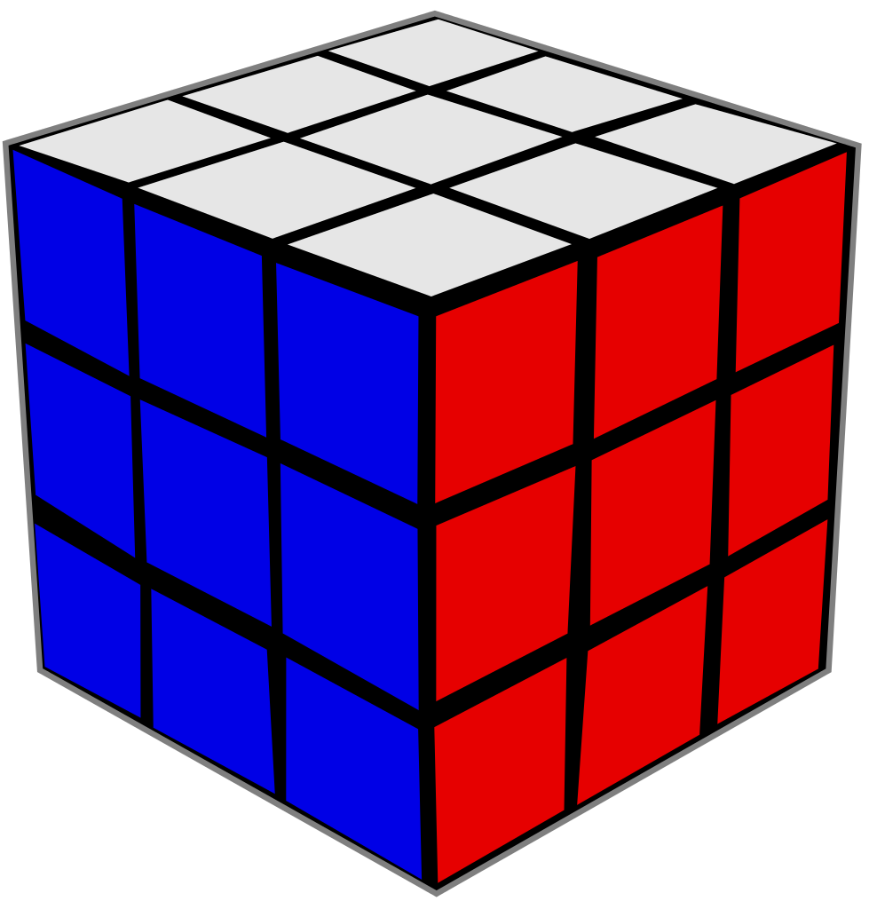 c. d. 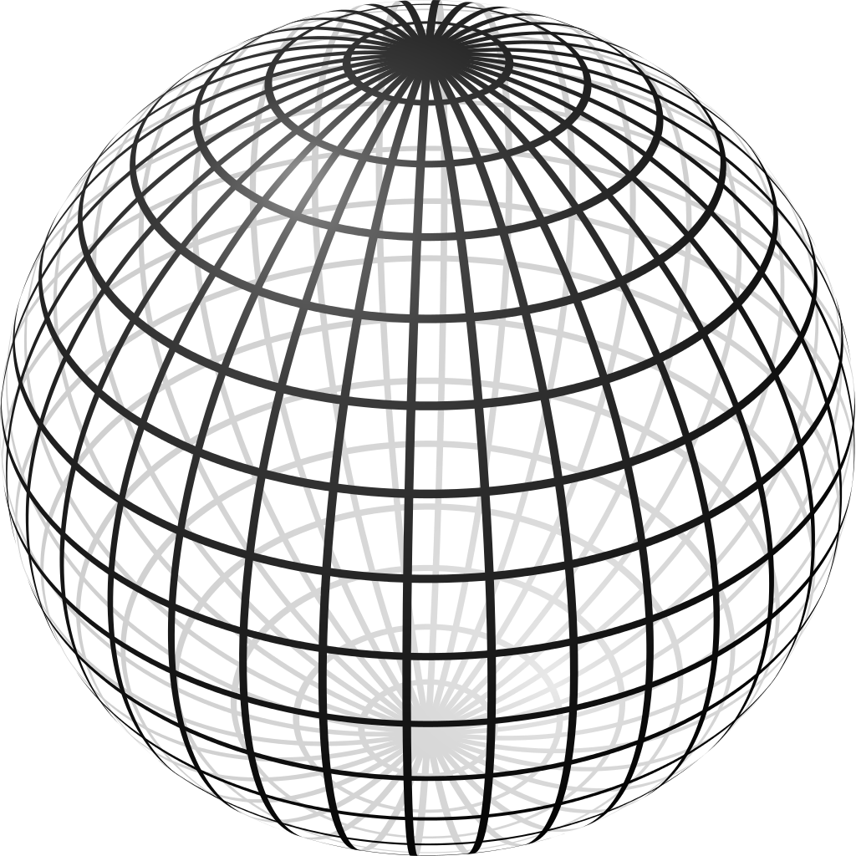 e.

- Which shape is the sphere?
- Which shape has is a 2-dimentional or flat shape?
- Draw 12 circles.

- Draw the 2 shapes with 3 sides?

- Draw a rectangle? How many vertices or corners does it have?

- Which picture shows the cylinder below the cube? a. b. c.

d.
- Fill in the blanks using the pictures:

5 - ______= 2 8 - _______ = 6

Language Arts projects for 4/27-5/1
- Sing the ABC song and write missing letters.
A B _______ D ________ F G ________ I
J _______ L M N _______ P Q ______
S _______ _______ V W _______ Y _______
- Write what letter each picture start with:
a. b. c. d. 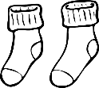 e.
f. g. 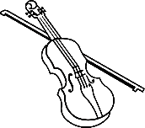 h. 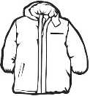 i. 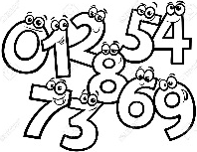 j.
k. l. 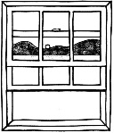 m. 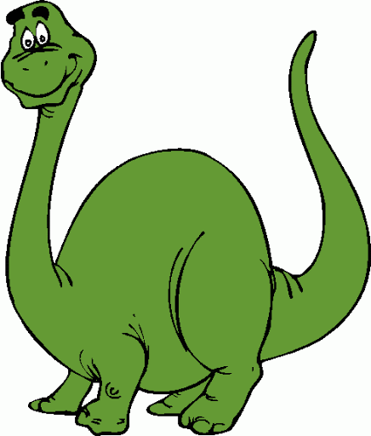 n. o. 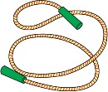
p. q. 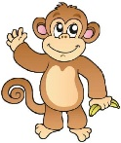 r.

- Read at least 3 stories using raz-kids or any other stories if you can't get online. Please make sure your student is only reading stories for their raz-kid account. I do keep track of how much they read.

- Make a card for a patient in a local nursing home. They can’t have any visitors and they are lonely. Ava’s mom works at a nursing home and will deliver them. Mail the cards to Tifani McKenzie at 2818 E. Glenn St., Tucson, AZ 85716

- Draw a picture to go with the memory verse.

