Language Arts instructions for 4/6-4/10 (#1 for 1st and 2nd only)
- Write the answers to the questions and take a picture of it. Send the picture to me by email or text it to me.
- Read at least 3 stories using raz-kids or any other stories if you can't get online. Please make sure your student is only reading stories for their raz-kid account. I do keep track of how much they read.
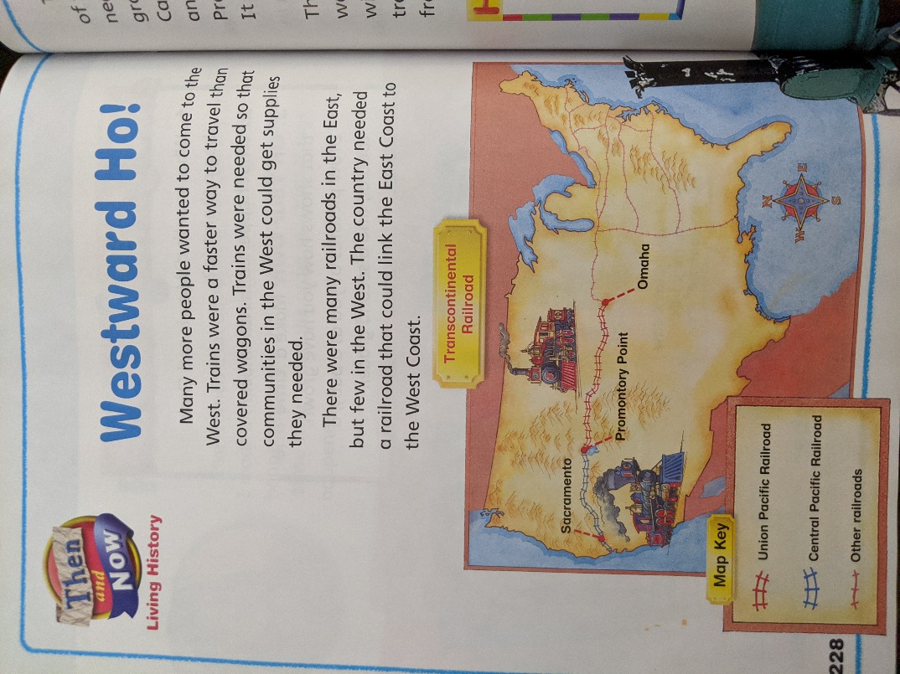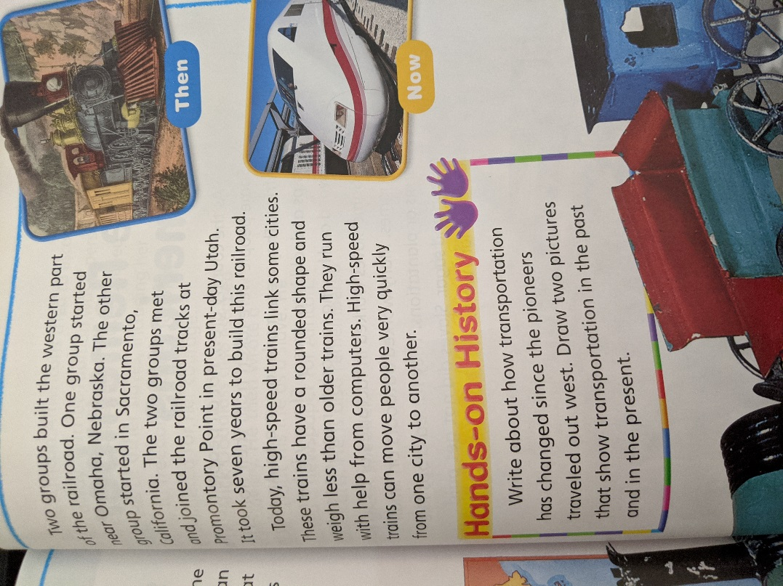

Science project instructions for 4/6-4/10:

- Answer the following questions and fill in the chart. Take a picture of your paper and send it to me by email or text.
- How do you stay clean?
- How can it keep you healthy?
- Fill in the graph to show how you stayed healthy each day.
Today I… | Monday | Tuesday | Wednesday | Thursday | Friday
exercised.
took a bath or shower.
washed my hands.
brushed my teeth.

Social Studies projects instructions for 4/6-4/10: (#2 for 1st and 2nd only)
- Ask your parents about their job and fill on the report. We will share our reports on Wednesday and Friday during our zoom meetings.
Job Report
- My ______________________’s job is __________________________________.
- Where do you work? _________________________________________________
- How did you learn your job?____________________________________________
____________________________________________________(school, training)
- What do you do at your job? ___________________________________________
___________________________________________________________________
- Why do you like your job? _____________________________________________
___________________________________________________________________
- Read the diagram to answer the questions on the page I am including.




