Math Projects for 4/20-4/20: Answer the questions on another piece of paper. Send a picture me by email or text.

- Make tally marks to show the following numbers:
  - 13 b. 10 c. 8 d. 3

- Make the clock say:
  - 2:30 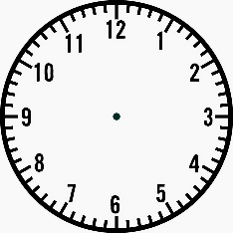 b. 5:00

- Which flat shape or shapes is part of each 3-D shape? None

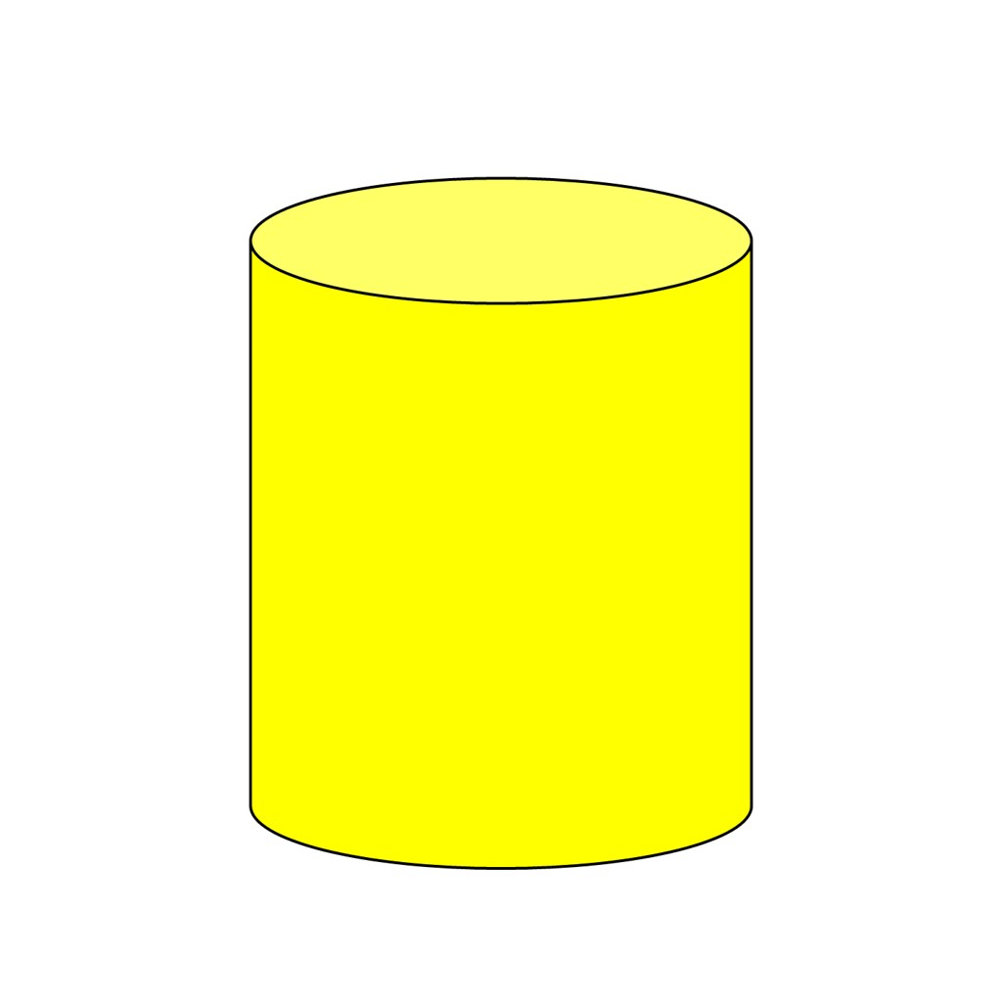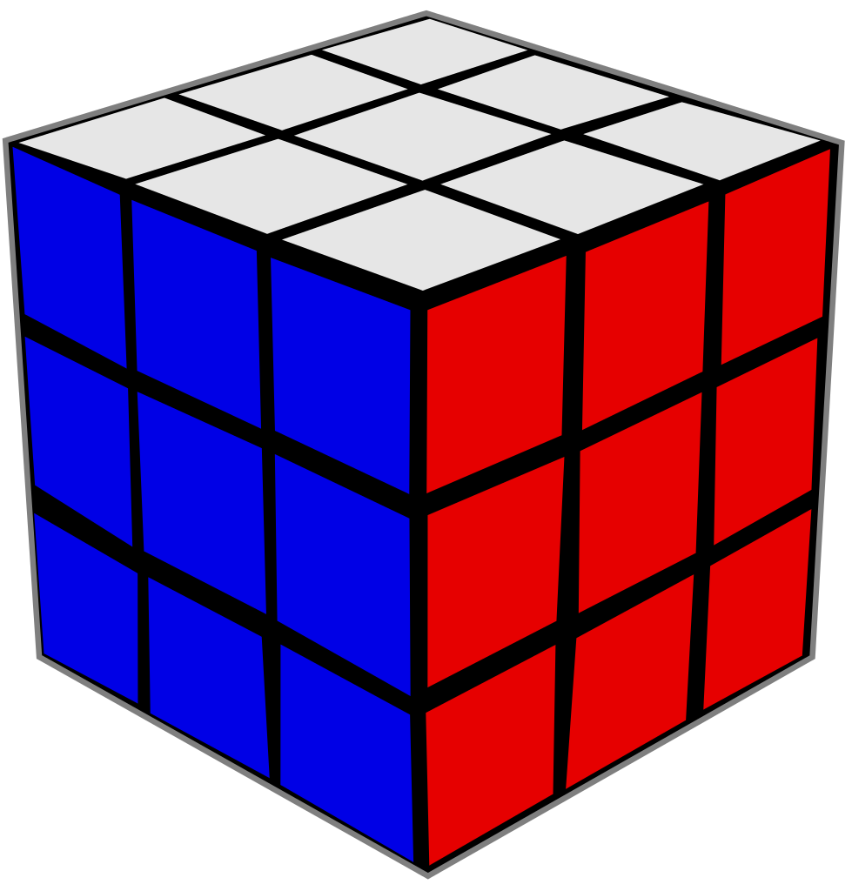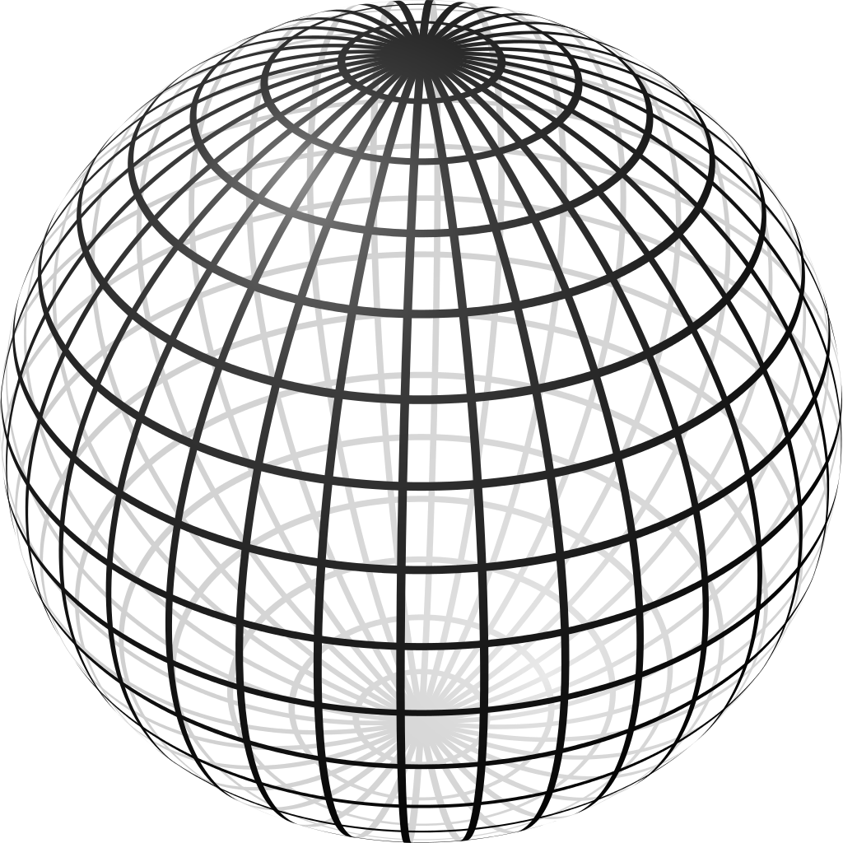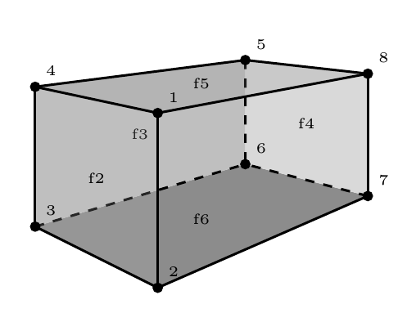
a. cylinder b. cube c cone. d. sphere e. rectangular prism

 | Favorite Activities
swimming | O O O
dancing | O O O O
drawing | O O O O O O

- a. How many more chose drawing than swimming?
b. How many chose dancing and swimming?

- Memorize your doubles facts for a quiz on Friday.
1+1= 4+4= 7+7= 10+10= 6+6= 9+9= 3+3= 5+5= 8+8= 2+2=
- Draw the smaller shapes inside the bigger shapes.

  - and b. and c. 2 d. 3

- Continue the patterns:
  - b. c.

Language Arts projects for 4/20-4/24

- Spelling- joy, come, love, boy, some, from, of, above, enjoy, none
  - Which words have an: oy om ome ove one

  - Put the words in alphabetical order.

- Phonics- Write the bold word that finishes the sentence.
  - One day Shane was (diving, driving, drive) home on Pine Lane.
  - He saw a hen and chicks (stand, standing, stands) still in the lane.
  - The hen was (pecking, pecked, pecks) in the mud.
  - Shane put the (braked, braking, brakes).
  - He got out and (picking, pick, picked) up the hen. Then he set her in the grass.
  - The chicks (dashed, dashing, dashes) across the lane
  - Shane (wave, waving, waved) to the drivers who were in the back of the truck.
  - All the drivers were (smiled, smiling, smiles) as they went by.

- English- Write each base word and add endings (pack+ing, pack+ed, rake+ing, rake+ed)
Base Word | dress | brush | spill | shave | bake | skate
+ed
+ing

- English- Write about your favorite holiday. What is it? Why do you like it? What do you do on that day?

- Handwriting- Write Psalm 46:1 as neatly as you can.

- Read at least 3 stories using raz-kids or any other stories if you can't get online. Please make sure your student is only reading stories for their raz-kid account. I do keep track of how much they read.

