Math Projects for 4/27-5/1: Answer the questions on another piece of paper. Send a picture me by email or text.

- Make tally marks to show the following numbers:
  - 17 b. 20 c. 28 d. 6

- Measure the height of something shorter than you and taller than you (if you don’t have a ruler use a pencil or blocks).
____________________ is _________ inches
____________________ is _________ inches

- Which flat shape or shapes is part of each 3-D shape?

a. b. c. d. e. 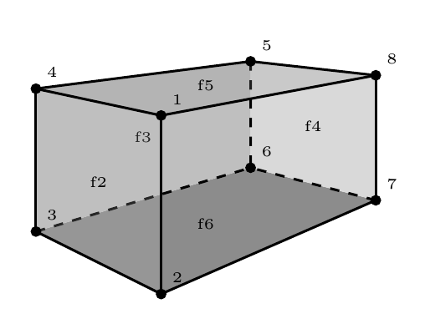

Favorite Exercises | 1 | 2 | 3 | 4 | 5 | 6
Bike Riding
Playing Ball
Hiking

- a. How many more chose bike riding than hiking?
b. How many chose playing ball and hiking?

- Memorize your doubles and doubles +1 facts for a quiz on Friday.
11+12= 4+5= 7+8= 10+11= 6+7= 9+10= 3+4= 5+6= 8+9= 2+3=
- Which shape shows:
half (1 of 2 equal parts) one-third (1 of 3 equal parts) one-fourth (1 of 4 equal parts)

  - b. c.

- Draw each shape and draw lines make it into the following parts:

a. b. c.
thirds halves fourths

Language Arts projects for 4/27-5/1

- Spelling- dish, fish, wish, finish, wash, shoe, shop, should, show, shut, shelf, shoes, short
  - Which words have an: ish ash sho shu she

  - Put the words in alphabetical order.

- Phonics- Write the bold word that finishes the sentence.
  - a thick (chain, pain, brain) f. a hot (stay, may, day)
  - five (snails, nails, tails) g. (gray, play, pay)
in the sand
  - (wait, bait, trait) for the bus h. a big (boat, coat, goat)
  - 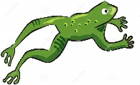a jumping (load, toad, road) i. (boat, float, coat)
in the lake
  - 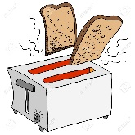hot (toast, roast, coast) j. (soak, oak, cloak) in
the tub

- English- Journal what you are doing every day. Write at least 3 sentences every day.

- English- Make a card for a patient in a local nursing home. They can’t have any visitors and they are lonely. Ava’s mom works at a nursing home and will deliver them. Mail the cards to Tifani McKenzie at 2818 E. Glenn St., Tucson, AZ 85716

5. Handwriting- Write Psalm 9:1 as neatly as you can.

- Read at least 3 stories using raz-kids or any other stories if you can't get online. Please make sure your student is only reading stories for their raz-kid account. I do keep track of how much they read.

